**2.POWER TRANSMISSION**

**[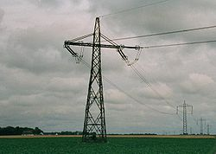](http://en.wikipedia.org/wiki/File:HVDCPylons.jpg)**

**2.1 Ac Power Transmission :**

Electric power transmission, a process in the delivery of electricity to consumers is the bulk transfer of electrical power. A Power transmission net work typically connects power plants to multiple substations near a populated area, at the generating plants the energy is produced at a relatively low voltage between about 2300v and 33,000v,depending on the size of the unit, the generator terminal voltage is then stepped up by the power station transformer to a higher voltage (66kv to 440kv ac ,varying by country) for transmission over long distances.

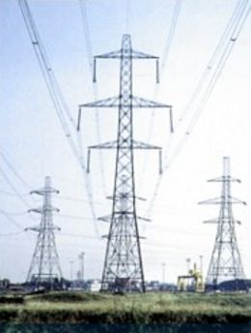

**Fig :2.1 Ac power transmission**

Usually transmission lines use three phase AC current, single phase AC current is sometimes used in a railway electrification system high voltage direct current systems are used for long distance transmission, or some undersea cables or for connecting to different AC networks.

**2.2 Types Of Ac Power Transmission :**

A transmission line has three constants R, L and C distributed uniformly along the whole length of the line. The resistance and inductance form the series impedance. The capacitance existing between conductors for 1 phase line or from a conductor to neutral for 3-phase line forms a shunt path throughout the length of the line. Therefore, capacitance effects introduce complications in transmission line calculations. Depending upon the manner in which capacitance is taken into account; The overhead transmission lines are classified as bellow.

* **Short Transmission Lines**

When the length of an overhead transmission line is up to about 50 km and the line voltage is comparatively low (<20kV), it is usually considered as a short transmission line. Due to smaller length and lower voltage, the capacitance effects are small and hence can be neglected. Therefore, while studying the performance of a short transmission line, only resistance and inductance of the line are taken into account.

* **Medium Transmission Lines**

When the length of an overhead transmission line is about 50-150 km and the line voltage is moderately high (>20kV<100kV), it is considered as a medium transmission line. Due to sufficient length and voltage of the line, the capacitance effects are taken into account. For purpose of calculations, the distributed capacitance of the line is divided and lumped in the form of condensers shunted across the line at one or more points.

* **Long Transmission Lines**

When the length of an overhead transmission line is more than 150 km and the line voltage is very high (>100kV), it is considered as a long transmission line.For the treatment of such a line, the line constants are considered uniformly distributed over the whole length of the line and rigorous methods are employed for solution.

**2.3 Advantages**

1. The Power can be generate at high voltage.
2. The maintence of AC substation is easy and cheaper.
3. The AC voltage can be step up or step down by transformer with ease and efficiency.

This permits to transmit power at high voltages and distribute it at safe potentials.

**2.4 Disadvantages**

1. An AC line requires more copper than a DC lines.
2. The construction of ac system ,the effective resistance of the line is increased.
3. An AC line has capacitance .therefore there is a continuous loss of power due to charging current even when the line is open.
4. Skin effect is a tendency for alternating current to flow mostly near the outer surface of a solid electrical conductor, such as metal wire,at frequencies above the audio range .the effect becomes more and more apparent as the frequency increases.